**DAILY ONLINE ACTIVITIES SUMMARY**

|  |  |  |  |  |  |  |  |
| --- | --- | --- | --- | --- | --- | --- | --- |
| **Date:** | | **28.5.20** | | | | | |
| **Name of the Faculty** | | **Dr.S.Mohideen Badhusha** | | | | | |
| **No. of Students Allotted for monitoring** | | | | | **18** | | |
| **Progress** | | | | | **good** | | |
| **Whether collected report from all the allotted students** | | | | | **17 students Github Accounts have been received so far and 4 members have updated their activities regularly. Rest of them are warned through mail and whatsapp to update properly** | | |
| **Online Test Summary** | | | | | | | |
| **Subject** |  | | | | | | |
| **Semester** |  | | | **Duration** | |  | |
| **No. of students Taken** | | |  | **Passing %** | |  | |
| **Certification Course Summary** | | | | | | | |
| **Course** | | **Introduction to Database Management** | | | | | |
| **Certificate Provider** | | **Alison** | | | **Duration** | | **(3 modules- 3 hours)** |
| **Coding Challenges** | | | | | | | |
| **Problem Statement: Python Program to Find the different digits r from numbers n** | | | | | | | |
| **Status: members have responded** | | | | | | | |
| **Uploaded the report in Github** | | | | | **yes** | | |
| **If yes Repository name** | | | | | **https://github.com/alvas-education-foundation/Dr.Sm.Badhusha** | | |
| **Uploaded the report in slack** | | | | | **yes** | | |

Certification Course Details: (Attach the snapshot and briefly write the report for the same

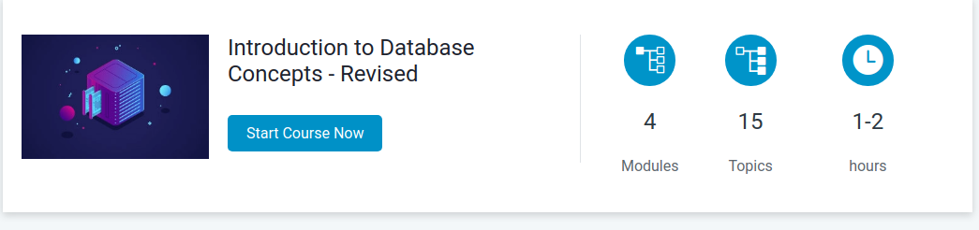

Coding Challenges Details: (Attach the snapshot and briefly write the report for the same)

